Client: Mr. Giovino

Solution: A web app that allows students to find peer tutors in a specific subject

Description: The user would either sign up as a student or as a tutor.

**IF TUTOR SIGN IN**: A list of all the available classes offered at portledge is displayed. The user will be able to click on whichever subject they want to tutor in. Then they input their name and a short description on why they want to tutor in that subject and their qualifications. Finally they submit their application to become a tutor. Before becoming a tutor you must be certified. To get certified, an email is sent to the teacher of the course you want to tutor. The email routes them to a link where they can certify or not certify the student to be a tutor. Once certified by the teacher, they are added to the database as a tutor for that subject.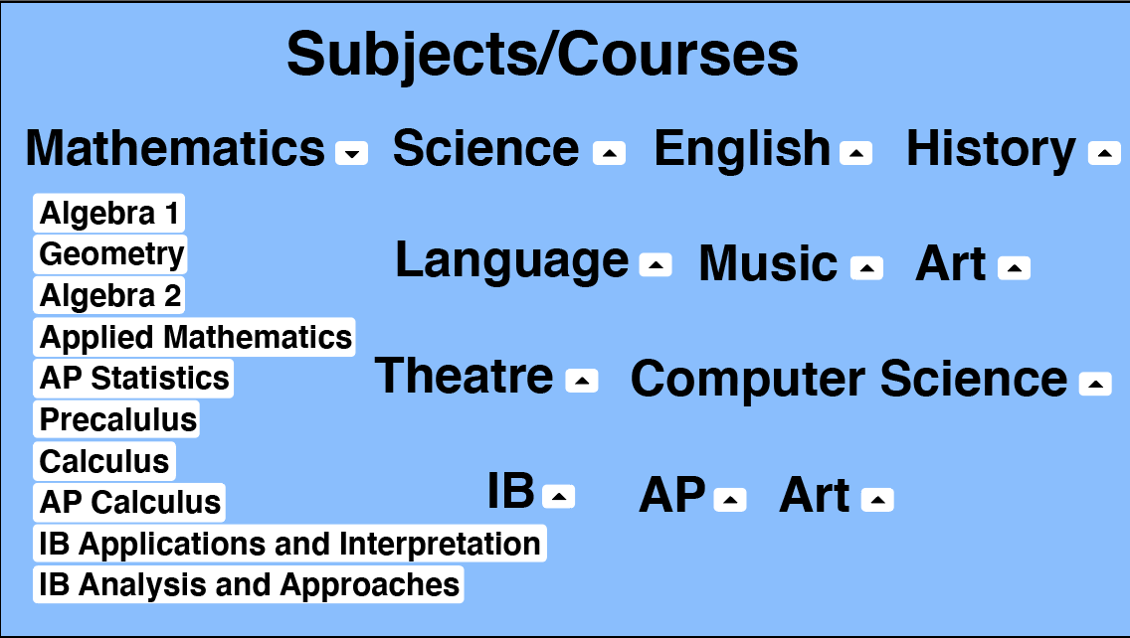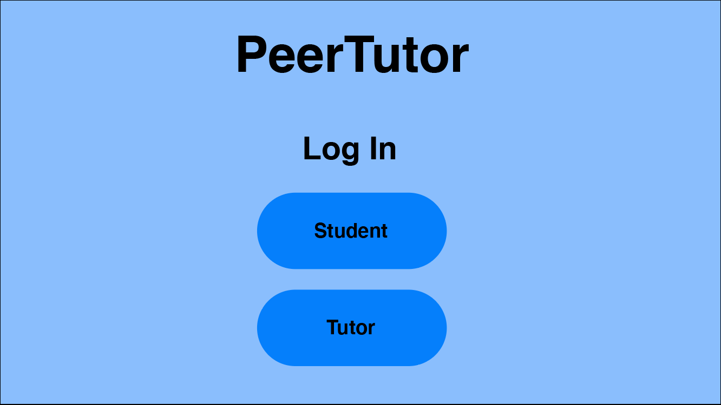

**IF STUDENT SIGN IN**: Similar to the tutor sign in, the student is met with a list of all available classes offered at portledge. The user will be able to click on whichever subject they want to be tutored in. If that course has a tutor available, they can choose which tutor they want. Then a request will be sent to the tutor by email.